**Assignment-7**

1. Homographs can be define as

A. Words with the Same Orthography and Different Meanings and Different Pronunciations

B. Words with Different Spellings and Different Meanings but the Same Pronunciation

C. Words with the Same Orthography and Different Meanings

2. Grapheme to Phoneme is the process by which

A. Determine the pronunciation of a word based on its spelling

B. Pronunciation of a word converted to its orthographic representation

C. Determine the parts of speech of the every word for a given sentence

3. Which one of the following synthesis method is a parametric synthesis method?

A. Di-Phone Synthesis

B. Unit selection

C. Element Based (ESNOLA)

D. Formant Synthesis

4. Which one of the flowing figures represents the labeling of a di-phone?

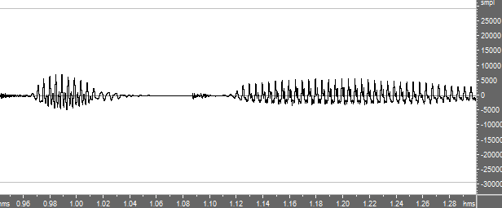

A



B



C.

5. Determine the number of consonant to vowel transition present in the phonetic representation of the word ‘bhaarat’ /bhɑrɑʈ/

A. 2

B. 3

C. 4

D.1

6. Which one of the following indicate the Limitations of the Statistical Approach based automatic speech recognition (ASR)

A. It does not make distinction between the spoken language and the written language

B. It is possible to use higher-order statistics beyond word trigrams

C. It makes distinction between the spoken language and the written language

7. Equation (1) represents the Statistical Approach based automatic speech recognition (ASR). In this equation P(A/W) can be determine from which kinds of modeling



A. Acoustic modeling

B. language modeling

C. Word modeling

8. Which one of the following is ambiguous in spoken language

A. flower/flour

B. Close

C. Record

D. Interest

9. Which one of the following is/are used as a Target cost in Unit Selection method based synthesis?

A. Phonetic context

B. Formants + other spectral characteristics

C. Energy

10. Pronunciation Lexicon Specification (PLS) of W3C is used for

A. Text to Speech Synthesis

B. Automatic Speech Recognition (ASR)

C. Both of the above